USER MANUAL:

- System Overview

The purpose of the Barangay System is to make sure of the efficiency because it will transform the old system into automated system. All the basic services of the barangay will be automated and all the data will be more secured and authentic. The objective of the system is to ensure efficiency and security. The application will be handled by the barangay officials and it will used by the masses. In case of transaction part will be on the barangay premises because if the requested document has a cost, the citizen will literally proceed to the barangay to receive his/her requested file and to pay for specific amount. The main process of the system is to collect information or data from the citizen who will be register and automatically display the standard format of registration form. The bulletin feature is to inform the citizens what are the events, news, tips, and updates of the specific barangay, also the system has the capability to give inform in health, documents and education.

  - Application
This provides general information on the physical and logical.

  - Dialog Flow
This section provides the screen messages and responses that the user needs to key-in.

  - User Security and Privacy
This section covers and explains the different user security requirements and policies. This will detail the different user security requirements and policies. This will detail the different levels of access that would be assigned to specific types of users.

  - User Operating Procedures
This section covers the different user administrative task related ton using the system (i.e., logon procedures).

- Site Map
This section explains the different module functions of the website.

ADMIN MANUAL:

Login

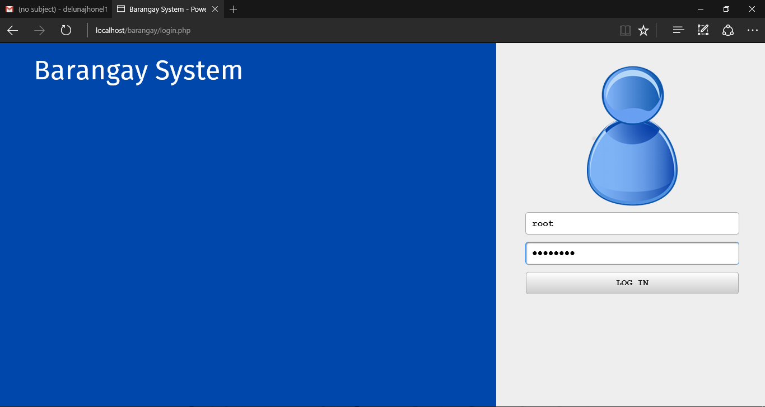

Login page:

1. Username: root (default)
2. Password: password (default)

Site management

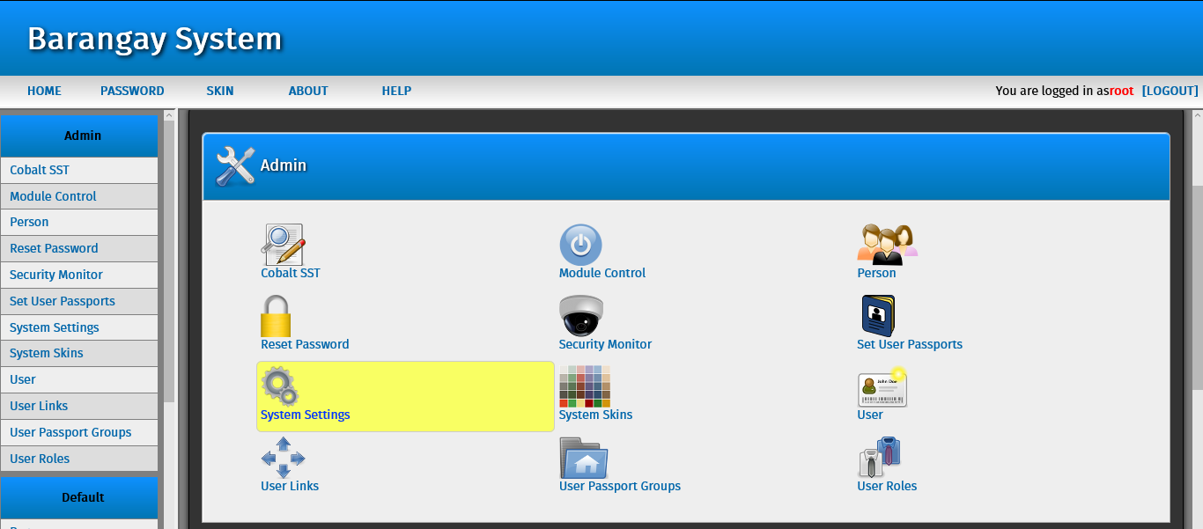

After login you will able to see this backend of the system (admin side).

In this page you able to manage this following important settings:

1. 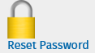 This icon is for changing the systems admin passwords.

2.  This is icon is to see the list of user or admin using this system.

3.  This icon is for changing the roles / permission of the admin.

User management

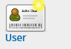 This icon is for creating another superuser or system admin.

After you click that icon you will need to see this page:

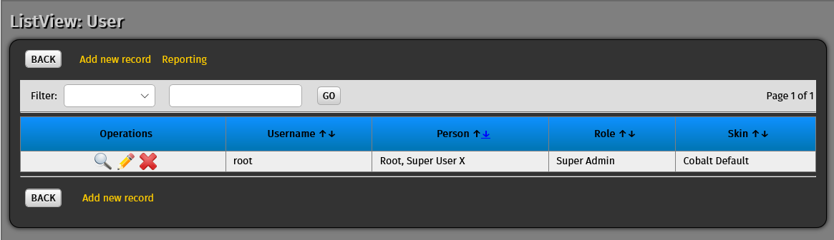

This is the list of all the admin as of now only root is the system admin and superuser but you can add another admin by clicking the “Add new record” button.

1.  This icon is use to edit the setting to selected user.

2.  This icon is use to view all the information of the selected user.

3,  This icon is use to delete user or admin in the site.

Add site user

To add another user click this . After clciking that icon and you will see a form then click 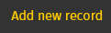 and you will see this form:

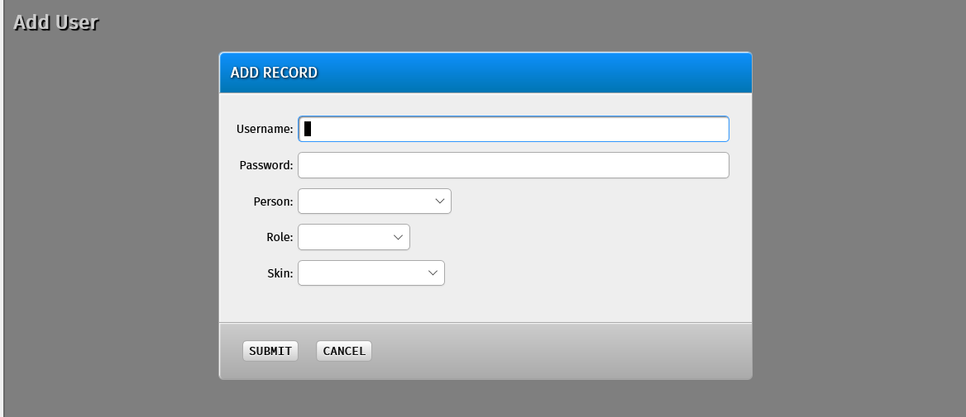

If you want make a new admin just fill up this for form and choose in the role if “System admin or Super user” the click submit.

List of table in the database:

1.  In this table you will able to add a official to the database.

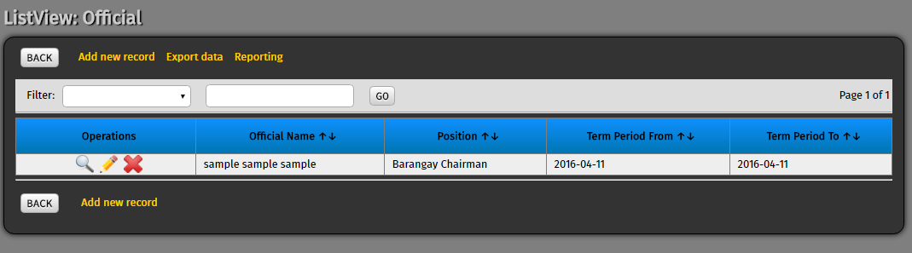

As you can see there is only one official, to another official just click and you will transfer to the registration form.

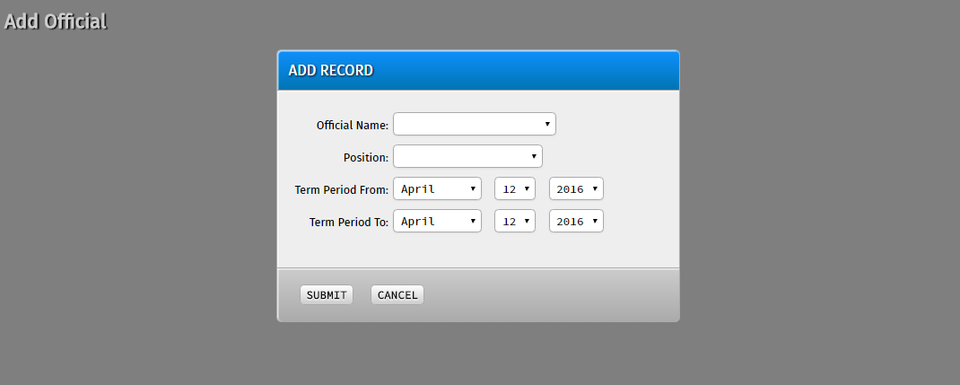

Make sure that you will fill up all the ask information because all the field is required to be filled, after filling up all the field then click .

2.  in this table you can add another services that your barangay will provide.

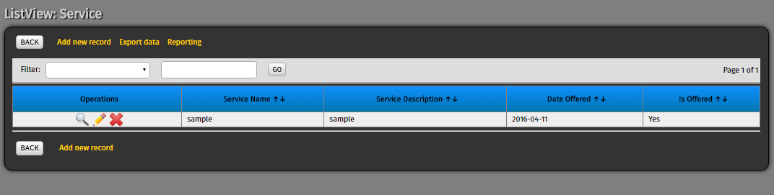

To another service just click and you will transfer to the registration form.

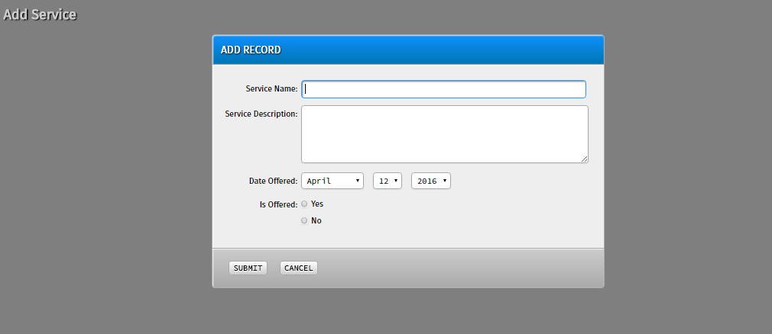

Make sure that you will fill up all the ask information because all the field is required to be filled, after filling up all the field then click .

3.  In this table you will able to see the list of all the user requested to your barangay and also in this table you need to put a status if the request is accepted or not accepted and waitlist for the system prompt the requestor.

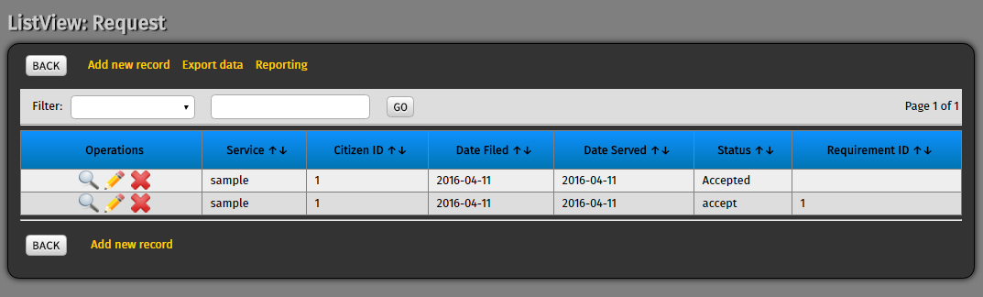

To add another request manually just click and you will transfer to another form

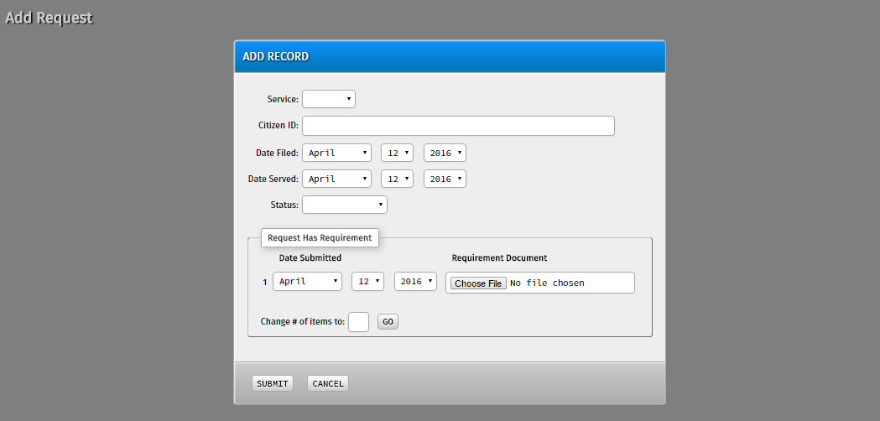

As you can see there is a portion of that form “Request Has Requirement” the citizen need to upload the required document and also you can request many just enter the number of your request  then click 

Make sure that you will fill up all the ask information because all the field is required to be filled, after filling up all the field then click .

4.  In this table will able to see the list of all the service and their respective requirements.

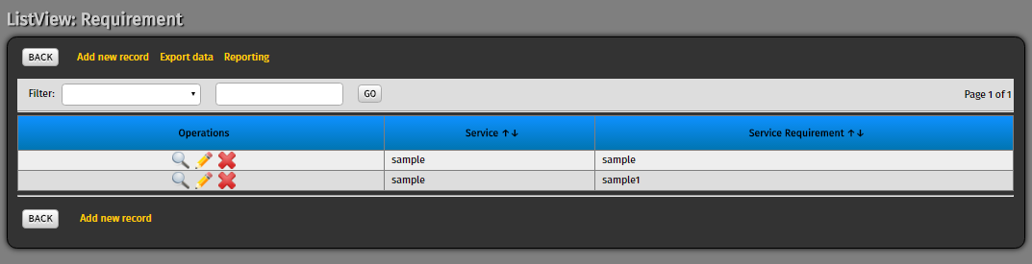

To add another requirement to a existing service manually just click and you will transfer to another form

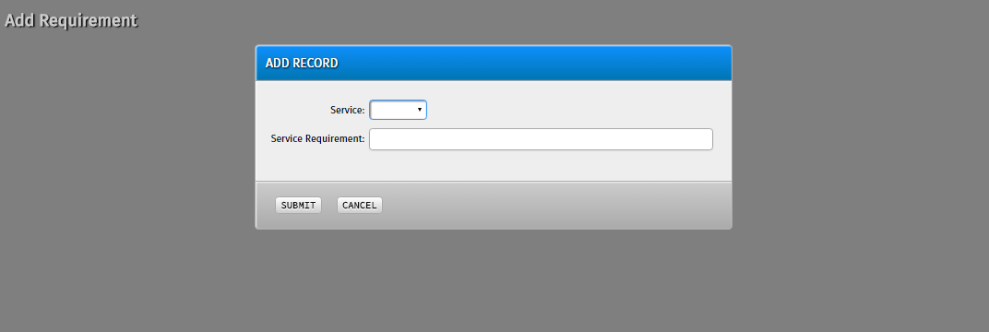

First you need to select a service to a requirement to it.

Make sure that you will fill up all the ask information because all the field is required to be filled, after filling up all the field then click .

5. 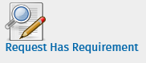 In this table you will able to see all the submitted requirements

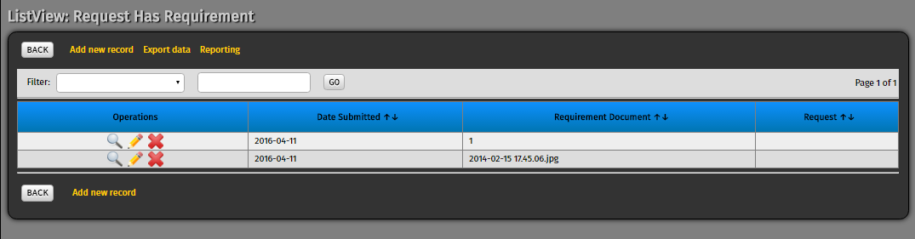

To upload another requirement to a existing service manually just click and you will transfer to another form



Make sure that you will fill up all the ask information because all the field is required to be filled, after filling up all the field then click .

6. 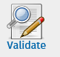 In this table the admin need to validate the submitted POA/POI of the citizen

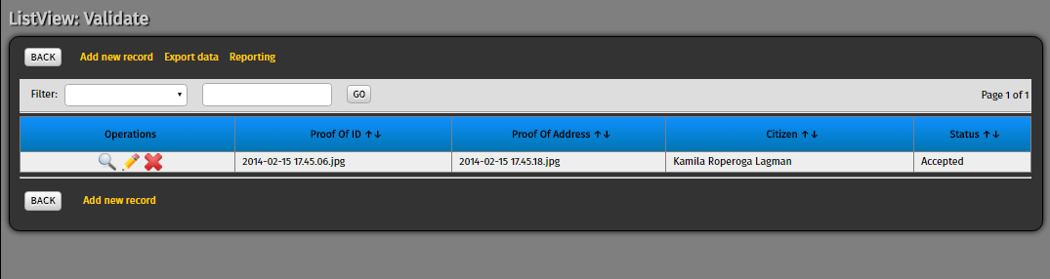

To add another record manually just click and you will transfer to another form.

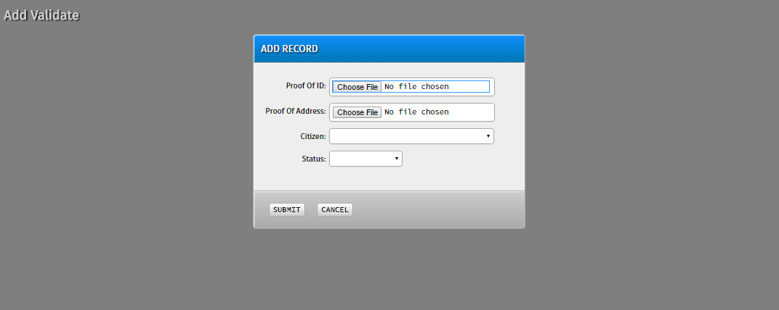

Make sure that you will fill up all the ask information because all the field is required to be filled, after filling up all the field then click .

7.  In this table you will able to see all the bulletin or announcment that the barangay will post in the main site.

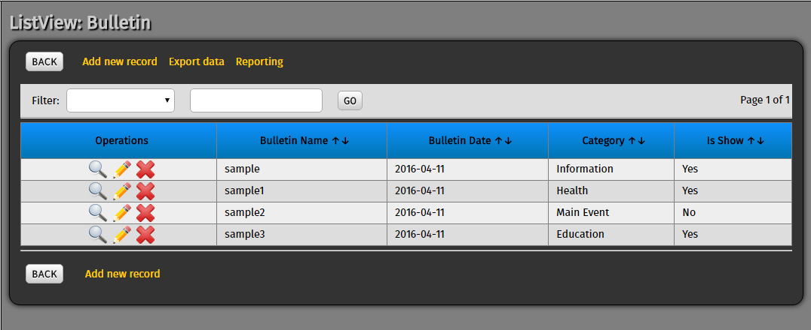
To add another announcement or event manually just click and you will transfer to another form.

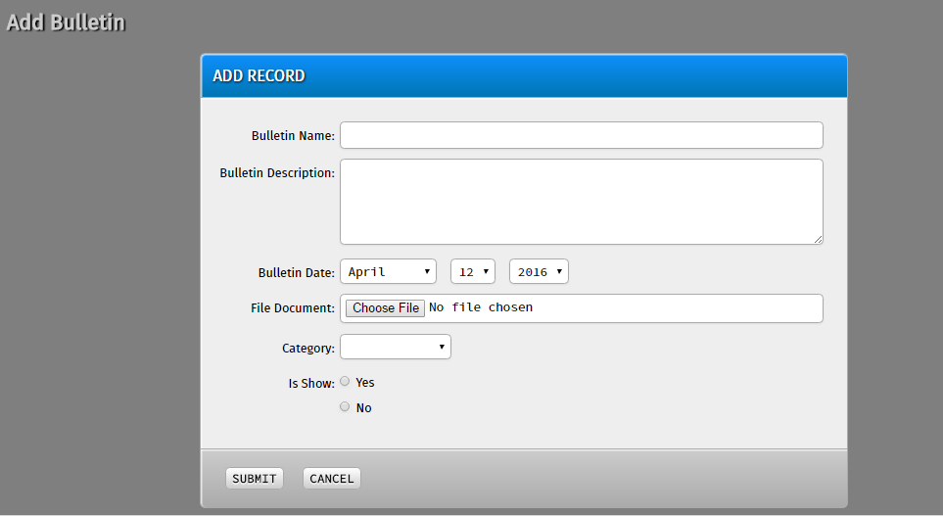

Make sure that you will fill up all the ask information because all the field is required to be filled, after filling up all the field then click .

8.  In this table the admin can send a letter to the citizen that request a service if their request is accepted or not.

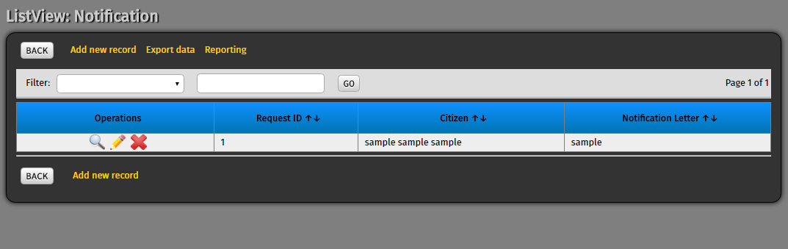

To add another notification manually just click and you will transfer to another form.

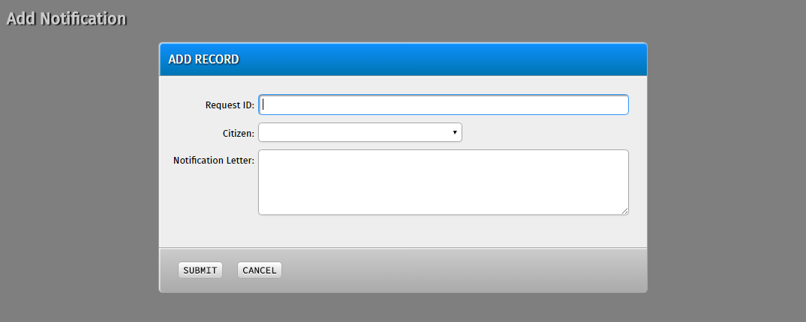

Make sure that you will fill up all the ask information because all the field is required to be filled, after filling up all the field then click .

9.  In this table you will able to see the list of all the regions in the Philippines.

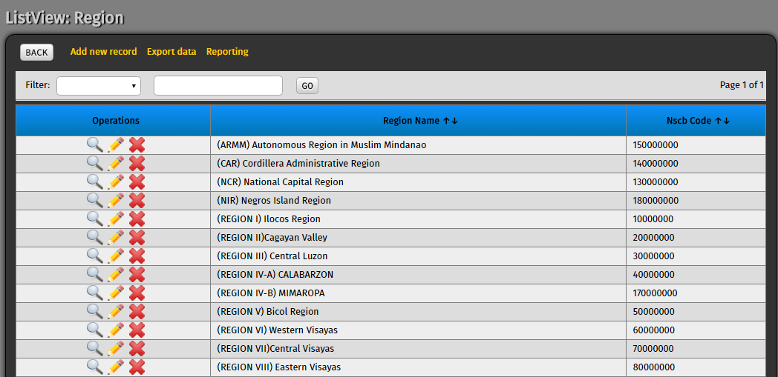

To add another region manually just click and you will transfer to another form.

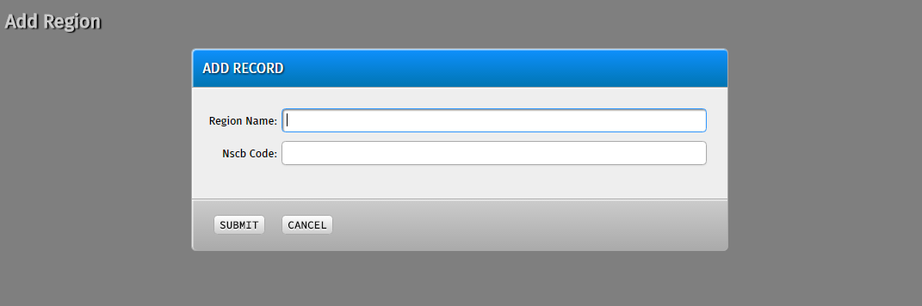

Make sure that you will fill up all the ask information because all the field is required to be filled, after filling up all the field then click .

10. In this table you will able to see the list of all the province in the philippines.

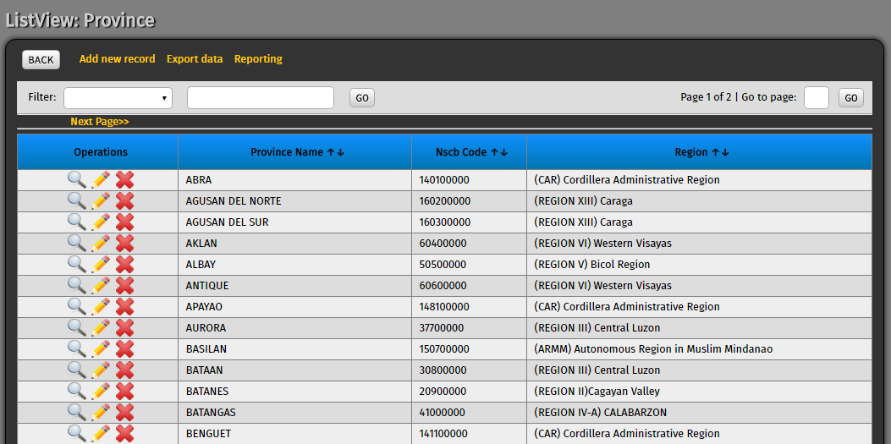

To add another province manually just click and you will transfer to another form.

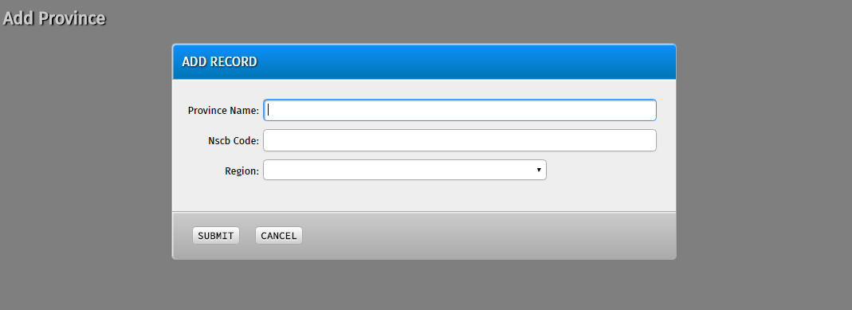

Make sure that you will fill up all the ask information because all the field is required to be filled, after filling up all the field then click .

11.  In this table you will able to see the list of all the city in the Philippines.

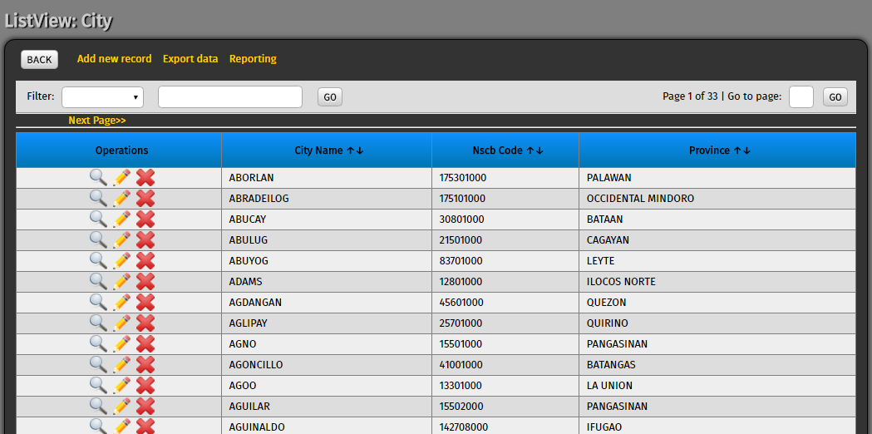

To add another city manually just click and you will transfer to another form.

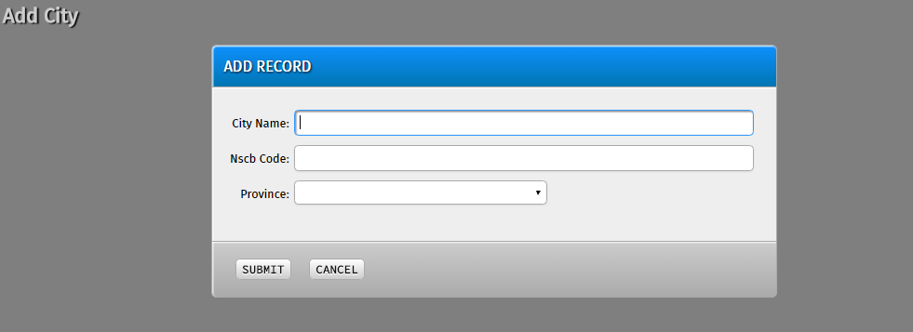

Make sure that you will fill up all the ask information because all the field is required to be filled, after filling up all the field then click .

12.  In this last table you will able to see the list of all the barangay in the Philippines.

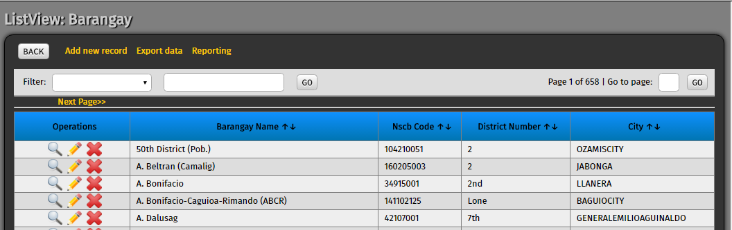

To add another barangay manually just click and you will transfer to another
Form

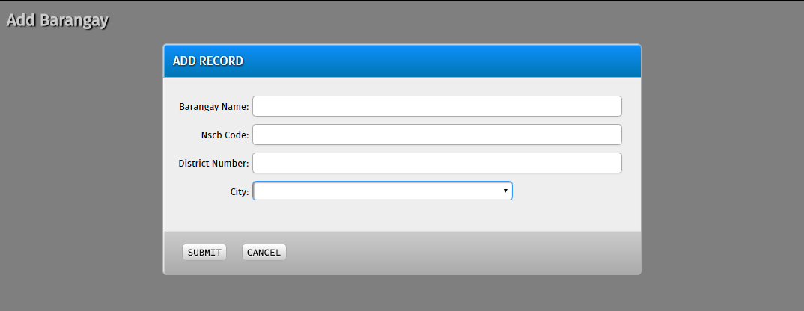

Make sure that you will fill up all the ask information because all the field is required to be filled, after filling up all the field then click .

